***Project Report on College Management System***

Submitted in partial fulfillment of the requirements

for the award of the diploma in Computer Science



**GOVERNMENT POLYTECHNIC COLLEGE, AMRITSAR**

**Submitted To: Submitted By:**

S. Harpreet Singh Soch Viresh Goyal - 100186206583

Raju - 100186206567

Bharat Rana - 10018620578

Anand Sehgal - 100186206529

ACKNOWLEDGEMENT

First of all I would like to thank Almighty God who has given wonderful gift of life to us. He is the one who is guiding us in the right direction to follow noble path of humanity. God has given us such an education and guidance from our respectful teachers by which we are using our talents in this kind of useful work. It is a matter of immense pleasure that I take opportunity to heartfelt gratitude to my Guide S. Harpreet Singh Soch, Lecturer, Department of Computer Science, Govt. Polytechnical College, Amritsar.

I would like to add my deepest gratitude for my entire faculty of **“**CSE Department**”** at **“**GOVERNMENT POLYTECHNIC COLLEGE**”**  from where I have learnt the basics which helped me a lot in completion of this project.Finally, yet importantly, I would like to express my heartfelt thanks to my parents for their blessings and wishes for successful completion of this work.

**ABSTRACT**

**The project is running with the help of Swing Programmingin Java Language. MySQL server is the back-end tool used in this project. I like to think of a programmer as a bit like a plumber! A plumber will arrive at a job with a big bag of tools and spare parts. Having looked at it for a while, he will open his bag and produce various tools and parts, fit them all together and solve your problem. Programming is just like this. You are given a problem to solve. You have at**

**Your disposal a big bag of tricks, in this case a programming language. You look at the problem for a while and work out how to solve it and then fit the bits of the language together to solve the problem you have got. The art of programming is knowing which bits you need to take out of your bag of tricks to solve each part of the problem. There are many things you must consider when writing a program; not all of them are directly related to the problem in hand. I am going to start on the basis that you are writing your programs for a customer. He or she has problem and would like you to write a program to solve it. Coming up with a perfect solution to a problem the customer has not got is something which happens surprisingly often in the real world. Many software projects have failed because the problem that they solved was the wrong one. The developers of the system quite simply did not find out what was required, but instead created what they thought was required.**

# Table of Contents

|  |  |  |
| --- | --- | --- |
| **S.No.** | **Particulars** | **Page No.** |
| **1** | Chapter 1 – Introduction   * Introduction to the project * Features of the Project * Profile of Assigned Problems * Proposed System * Modules of the project | **6-13** |
| **2** | Chapter 2 – Objective of Project Work   * Objectives * Design Constraints * E-R Diagrams * Class Diagrams * Flowcharts | **14-32** |
| **3** | Chapter 3 – Literature Review   * Introduction * Packages used * Development Tools To Be Used * Hardware and Software Requirements | **33-50** |
| **4** | Chapter 4 – Present Work   * About Project * Snapshots related to the Project * Database Tables of the Project | **51-66** |
| **5** | Chapter 5 – Conclusions and future scope   * Benefits of the Project * Conclusion * Further Scope of Project in Future * Maintenance * References | **66-71** |

Chapter 1- Introduction

* **Introduction to the Project**

The name of the project is College Management System. The topic of our project is very diverse as it will manage a college which is itself a huge organization which imparts knowledge but for its proper working many other things work all the time along with studies. The aim of project is to manage each and every required section a software can handle with accuracy eliminating many mistakes that a person on job performs due to any reason and makes the operations even faster. Every department for us is a module and has independent working criteria but in one way or the other they are related with one other and collecting these modules a college is formed which we have to manage. This project handles various types of work related to a college where policy of college may be of different type. It provides a better and an efficient way to handle all the data and purposes related to a college. The project is designed n java programming language and its various features are used to design a college project where it allows its admin to do whatever changes he wants to make in the college. The admin can manage all data related to a college by various ways and excessive privileges are allowed to him to handle the college system. The project provides security to its users and the admin with the help of usernames and passwords. Only the person having the correct username and password is allowed to run the project. Variable amount of security is also provided in Change Password and Add New User modules. While changing the password related to a specific user account, the user has to enter the correct existing username and password. If the username and password does not matches the entries in the database then he is not allowed to do so. Similarly, While adding a new user to the database, the user has to provide authentication by entering any existing user account and the password related to that account. If the entered details are wrong, then security is compromised and the user is not allowed to make the changes. The system enables the admin to work on five major modules of the college. Student information is entered in the Student module. The admin can add information to the module, view that information, update that information and can also delete that information. Proper validations are used while filling that information by the admin. He must enter the correct data in proper format. There is also an Employee module to handle the staff information of the college. There also admin can add, view, delete, update and refresh the information. Necessary validation are also applied while accepting the data from the user. This module is the important module of this system for Library Management in college. The admin can add book in the library by issuing a new book id to any new book and fill details of book’s name and the name of the author. Proper validations are provided for book id and names. The admin can also delete any available book in the library by entering its book id. He can also issue or unissue any available book to a student by entering his registration number. Data validations are also checked on this phase. At any time he can search for any book that either it is available in the library or not or either it is issued to a particular student. Security is provided by matching the registration numbers while un-issuing a book. Hostel Management is done in this module of the project. The admin can allocate or un-allocate a room to the particular student by entering the room number and the registration number of the student. Proper data validations are applied on each process. We can also search for the room at any time by entering the room number that whether it is allocated to a particular student or not.

* **Features of the Project**
* It is a comprehensive student information management system developed from the ground up to fulfill the needs of independent Colleges as they guide their students to success. The Education Edge integrated information management system connects daily operations in the College environment ranging from Admissions and Registration to Finance, Faculty, Medical and Business Development. This reduces data error and ensures that information is always up-to-date throughout the College.
* It provides a single source of data repository for streamlining your business processes and reporting purposes.
* It has a simple user interface and is intuitive. This insures that the users spend less time in learning the system and hence, increase their productivity.
* Efficient security features provide data privacy and maintains data integrity.
* You can send email messages and notices to an individual or department.
* Enables easy modifications , easy collaboration over the internet and offers complete life-cycle management for your business processes.
* Supports your institution’s daily operations by eliminating duplicate data entry , sharing the most up-to-date information, maintaining a detailed history of essential records.

* **Profile of Problems Assigned:**
* Develop a module in which the admin can fill the customer form.
* Develop a module in which the admin can check the Status of customer’s data and transaction’s.
* Develop an module in which admin can manage and access the whole database and pages of the Windows form. The login level for admin, and users will be different and there must be some security code to prevent any person to access the data without login.
* The GUI part of the project should be user friendly.
* **Proposed System:**

The benefits of the proposedsystem must also be evaluated. Benefits may be categorized as tangible or intangible. Tangible benefits which are measured in money terms consist of the saving of:

* Time.
* Certain operating costs.

Intangible benefits are more difficult to estimate and justify. They are often impossible to give a money value to. These may include –

* Satisfaction of the clients
* Efficiency.

**Advantages of Proposed System:**

* **User friendly interface:** The proposed system provides a user friendly interface. The graphical user interface is provided in the proposed system, which provides user to deal with the system very easily.
* **Fast access to database:**In the proposed system all data can be accessed fast and easily. The entire database is stored at one place and different users can access it concurrently. So work can be done speedily and in time.
* **Less error:**Constraints will be there so no chance of error in the proposed system**.**
* **More Storage Capacity:**The proposed system has huge storage capacity. Storing and retrieving information is easy.
* **Modules of the Project**
* **Student Module**

The Student module is an very important part of the project. Student information is entered in the Student module. The admin can add information to the module, view that information, update that information and can also delete that information. Proper validations are used while filling that information by the admin. He must enter the correct data in proper format. We have applied our checks on the registration number that it should be in proper numerical format and must be of specified digits. Name fields like that of student name and guardian’s name should only contain valid alphabetic characters. Email address validations and contact number validations are also applied on the data. The admin can view, delete or update the data by entering the proper registration number of the student.

* **Admissions Module**

In this module of the project, Student Admissions are added to the college. Student information is entered in this module along with the date of admission of the student. The admin can add information to the module, view that information, update that information and can also delete that information. Proper validations are used while filling that information by the admin. He must enter the correct data in proper format. We have applied our checks on the registration number that it should be in proper numerical format and must be of specified digits. Name field should only contain valid alphabetic characters. Whenever the new student admission is to be added, the current date and time of the server machine is fetched to keep the correct records of the admissions. The date and time of the student admission cannot be updated either at the time of admission or by update data module. It can only be deleted along with the student admission.

* **Employee Module**

The Employee module is used to manage employee information in the system. Employee data is entered in this module. The admin can add information to the module, view that information updates that information and can also delete that information. He also can refresh the employee database. Proper validations are used while filling that information by the admin. He must enter the correct data in proper format. We have applied our checks on the employee id that it should be in proper numerical format and must be of specified digits. Name field should only contain valid alphabetic characters. The admin can view the employee information in the form of a table. The department and designation fields are accepted with the help of combo boxes to provide ease to the user. The user can see the information in the grid format and can make changes to the selected data in that format.

* **Library Module**

This module is the important module of this system for Library Management in college. The admin can add book in the library by issuing a new book id to any new book and fill details of book’s name and the name of the author. Proper validations are provided for book id and names. The admin can also delete any available book in the library by entering its book id. He can also issue or unissue any available book to a student by entering his registration number. Data validations are also checked on this phase. At any time he can search for any book that either it is available in the library or not or either it is issued to a particular student. Security is provided by matching the registration numbers while un-issuing a book.

* **Hostel Module**

Hostel Management is done in this module of the project. The admin can allocate or un-allocate a room to the particular student by entering the room number and the registration number of the student. Proper data validations are applied on each process. We can also search for the room at any time by entering the room number that whether it is allocated to a particular student or not.

Chapter 2- Objective of Project Work

**Objectives:**

The objective of our project is to develop a GUI(Graphical User Interface) based software that is platform independent and user friendly and which can be fit into any college system. It will remove data redundancy and will be fast in operation. The main problems with present college management software are:-

* Platform Dependency
* Data Redundancy Problem
* Slow in Execution
* Do not cover all the modules that should be present for a college management software.
* Threat to security level
* Improper Beginner Tutorials

Our software overcomes all these problems faced by any college management software.

Though a college management software is actually custom based as it is developed for meeting the requirements of a particular college, but we have created the project as a global one which can satisfy the needs of all college system.

Features included in our software are:-

* **Platform Independent :-**As our software is coded in java, so it is platform independent that is it can work on any operating system, whether it be any version of Microsoft windows(98 ME XP VISTA 7), LINUX, UNIX or any other. Reduced data redundancy as we are using RDBMS in the back end of our software, so it will overcome the problem of data duplicity.
* **Fast Execution: -** As our software is GUI based, it contains many new features which will make the execution faster than any other pre-existing software.
* **Cost Efficient: -** Due to removal of data redundancy from the software duplicity of data is eliminated and wastage of memory is overcome. As we know that storage devices are cost consuming so by saving space we are saving money and providing a cost effective software.
* **Inbuilt Security: -**Our software includes better security levels with inbuilt antivirus and anti-hacking facilities which will support the pre-installed antivirus and anti-hacking software’s.

College management is an important issue, since it is well recognized that senior managers in

Colleges have a major impact upon classroom and curriculum practices, and that the use of College. WithinColleges is permeating aspects of College practice to the extent that it will impact upon the Practice of all staff (both teaching and non-teaching). The purpose of this review is to begin a Process of investigating the width of literature across this field, to find areas of pertinence that Can add to our understanding of current practices and current needs. The review arose from the Discussions and feedback at a research conference organised by Becta in the summer of 2001. This current review provides an indication as to the research available in this field, identifies some key documents and emerging messages, and suggest priority areas for future research.

* College is totally based upon data base and windows Programming has SQL server that is a most important advantage of windows programming that’s why I decided to prepare project on College.
* Admin is a person who handle the staff database.They have all kind of authorities to access staff database to view data, update data, and delete data, staff data. The following are the main points of student data.in view data we view the data row wise or column wising update data we can update one or more information of staff.in delete data we can delete specific staff data. Staff salary contain pay salary, view pay salary.
* Educational change (this category covers the literature concerned with the reasons for educational change, and the effects and impacts resulting, particularly at an individual teacher or manager level).
* Management of change (this category covers the literature concerned with the conception of management of change principles, approaches and methods adopted in order to bring about change, and to consider attitudes to change).
* Management approaches (this category covers the literature concerned with management approaches in general, but more specifically with the types of management approach that lend themselves to particular purpose or outcomes, and the implications).
* The College management project contain seven modules each module has there specific meaning but the main module are admin module, student module, user module. Because these modules are totally based upon database sql server 2008. The project contain six tables four for student database that are all student database, student result, scholarship form, College fee and two staff tables that are all staff and staff salary.
* COLLEGE management (this category covers the literature concerned with how COLLEGE is managed within organizations, and the concerns and issues that face managers and others in respect of COLLEGE).
* Strategic and tactical approaches (this category covers the literature concerned with the types of approach that are involved when change and COLLEGE use is introduced into organisations and systems, and the impacts that this has upon support and personnel particularly).
* Personnel management (this category covers the literature concerned with how the introduction of COLLEGE is shifting the needs for personnel within organizations and institutions, and the future implications that there might be in these respects).
* Resource and resource development management (this category covers the literature concerned with how resources that are COLLEGE-based can both be developed in a range of ways and by a variety of groups, and how their uses are managed within educational situations).
* Financial and procurement management (this category covers the literature concerned with aspects of finance and procurement that managers in educational situations now need to consider).
* Planning and project management (this category covers the literature concerned with the approaches and needs for planning and project management when different COLLEGE uses are being introduced into educational situations).
* Managing sustainability (this category covers the literature concerned with the ways in which managers in educational situations are now considering maintainability and sustainability, and the implications that arise for the future).
* Monitoring and evaluation processes in College management is very these are explained in help and about us module.

**Design Constraints: -**

There are number of factors in client’s environment that may restrict the choices of a designer. Such factors include:

1. **Standards Compliance: -** The basic standard for the proposed system is that the Server should never crash under any circumstances.
2. **Hardware Limitation: -** There is no hardware limitation to be specified.
3. **Reliability and Fault Tolerance: -** The proposed system should be highly reliable and must be fault tolerant. Probably there will not be any fault, and if any fault occurs then better to restart the Server.
4. **Security: -** The existing system is highly secured, and no further security is needed for proposed system.

## Class Diagrams:-The things naturally fall into categories we refer to those categories as classes. A class is a category or group of things that have similar attributes and common behavior.Java class file is a [file](http://en.wikipedia.org/wiki/Computer_file) (with the .class [filename extension](http://en.wikipedia.org/wiki/Filename_extension)) containing a [Java bytecode](http://en.wikipedia.org/wiki/Java_bytecode)which can be executed on the [Java Virtual Machine (JVM)](http://en.wikipedia.org/wiki/Java_Virtual_Machine). Java class file is produced by[Java compiler](http://en.wikipedia.org/wiki/Java_compiler) from [Java programming language](http://en.wikipedia.org/wiki/Java_(programming_language)) [source files](http://en.wikipedia.org/wiki/Source_file) (.java files) containing Java [classes](http://en.wikipedia.org/wiki/Class_(programming)). If a source file has more than one class, each class is compiled into a separate class file.

* Class College Management

CollegeManagement

StartPage.java

+ Swing Components

+ Action Listener

+void actionPerformed()

Home.java

+ Swing Components

+ Action Listener

+Call Other Classes

* Class Diagram for Changing Password.

ChangePassword

+ Swing Components

+ Action Listener

+void actionPerformed()

Database Coding to match existing username and password and then change to new password

* Class Diagram for Adding New User Account

AddUserAccount

+ Swing Components

+ Action Listener

+void actionPerformed()

Database Coding to match existing username and password and then add a new username in the database

* Class Students

Students

+ Swing Components

+ Action Listener

+void actionPerformed()

+ Add Student Data

+ View Student Data

+ Update Student Data

+ Delete Student Data

* Class Admissions

Admissions

+ Swing Components

+ Action Listener

+ void actionPerformed()

+ TableModel

+ Add New Admission

+ Update Student Admission

+ Delete Student Admission

+ Refresh Student List

* Class Employees

Employees

+ Swing Components

+ Action Listener

+ void actionPerformed()

+ TableModel

+ Add Employee

+ Update Employee Info

+ Delete Employee

+ Refresh Employee List

* Class Library

Library

+ Swing Components

+ Action Listener

+ void actionPerformed()

+ Search Book

+ Add Book

+ Delete Book

+ Issue Book

+ Unissued Book

* Class Hostel

Hostel

+ Swing Components

+ Action Listener

+ void actionPerformed()

+ Search Room

+ Allocate Room

+ Unallocated Room

**ER DIAGRAM OF THE PROJECT:**

COLLEGE MANAGEMENT

STUDENTS

EMPLOYEES

LIBRARY MANAGEMENT

HOSTEL MANAGEMENT

**FLOWCHARTS RELATED TO PROJECT:**

ENTER ANY EXISTING USERNAME AND THE RELATED PASSWORD FOR AUTHENTICATION

IF THE USER DATA IS MATCHED IN THE DATABASE?

NEW USER ADDED

USER CANNOT BE ADDED! PLEASE ENTER THE CORRECT EXISTING USERNAME AND PASSWORD

ENTER THE USERNAME AND CURRENT PASSWORD. ALSO ENTER NEW PASSWORD AND CONFIRM NEW PASSWORD

DOES THE USERNAME AND PASSWORD MATCH IN DATABASE?

PLEASE ENTER THE CORRECT USERNAME AND PASSWORD

DOES THE NEW PASSWORD MATCHES WITH CONFIRMED PASSWORD?

PASSWORD CHANGED!

NEW PASSWORD NOT CONFIRMED!!

ENTER THE REQUIRED INFORMATION OF STUDENTS OR EMPLOYEES

HAS THE USER ADDED OR UPDATED THE DATA IN PROPER REQUIRED FORMAT?

MAKE CHNAGES OF THE ADDED OR UPDATED DATA IN THE DATABASE

CHECK FOR DATA VALIDATIONS ON VARIOUS DATA FIELDS.

Chapter 3- Literature Review

* **Introduction**

This Package has been developed in **Java**, which is based on Object Oriented Methodology. There are several packages resided in Java and to develop this system, mainly networking, swing packages of Java are used. Various features of Java made it a first choice of the programmers. Java is a platform independent language, which can be run under any kind of environment.

The main features involve,

1. **Simple**: - Java is a language which is based on Object Oriented Methodology, so it is very easy to learn and can be used effectively.
2. **Robust**: - Java Programs are said to be robust because they will take care of memory management and will never crash under any circumstances.
3. **Secure**: - Even though Java is developed using Object Oriented Principles, it eliminated the Pointers Concept. So it is not possible to access memory directly, that’s why Java is said to be Secure and is applicable for Internet, for that Applet is designed which can be understandable by the browsers.
4. **Portable**: - Java Programs are Portable that those can be run under any kind of environment irrespective of the hardware used. This is known as platform independent.
5. **Compiled & Interpreted**: - Unlike remaining Programming languages Java code is both Compiled and Interpreted. The output after compilation is ‘Byte Code’ which is interpreted to produce output. This Byte Code is a new evolution, which makes Java a Platform Independent Language.

**Packages Used: -**

1. The default package to build any program in Java is **lang** that is used in developing this system
2. The API to build Graphical User Interface in Java is provided using the packages **awt** and **swing**. This system uses both the packages to provide GUI based forms..
3. In Java JDBC (Java Database Connectivity) is used to connect to the database, a special package known as **sql** is developed for that.
4. The **util** package in Java is an enhancement of the existing classes. This package is also used in this system for declaring arrays (Vector), and to manipulate the strings.
5. The streams that are used to send and receive the data over network are also utilized in this system, which are in the package of **io**.

**INTRODUCTION TO SWING:**

In Part II, you saw how to build user interfaces with the AWT. Although the AWT Is still a crucial part of Java, its component set is no longer widely used to create graphic user interfaces. Today, most programmers use Swing for this purpose. Swing is a set of classes that provides more powerful and flexible GUI components than does the AWT. Simply put, Swing provides the look and feel of the modern Java GUI.

Coverage of Swing is divided between two chapters. This chapter introduces Swing. It begins by describing Swing’s core concepts. It then shows the general form of a Swing program, including both applications and applets. It concludes by explaining how painting is accomplished in Swing. The following presents several commonly used Swing components. It is important to understand that the number of classes and interfaces in the Swing packages is quite large, and they can’t all be covered in this book. (In fact, full coverage of Swing requires an entire book of its own.) However, these two chapters will give you a basic understanding of this important topic.

Swing did not exist in the early days of Java. Rather, it was a response to deficiencies present in Java’s original GUI subsystem: the Abstract Window Toolkit. The AWT defines a basic set of controls, windows, and dialog boxes that support a usable, but limited graphical interface. One reason for the limited nature of the AWT is that it translates its various visual components into their corresponding, platform-specific equivalents, or peers. This means that the look and feel of a component is defined by the platform, not by Java. Because the AWT components use native code resources, they are referred to as heavyweight. The use of native peers led to several problems. First, because of variations between operating systems, a component might look, or even act, differently on different platforms. This potential variability threatened the overarching philosophy of Java: write once, run anywhere. Second, the look and feel of each component was fixed (because it is defined by the platform) and could not be (easily) changed. Third, the use of heavyweight components caused some frustrating restrictions. For example, a heavyweight component is always rectangular and opaque.

**A Simple Swing Application:**

Swing programs differ from both the console-based programs and the AWT-based programs shown earlier in this For example, they use a different set of components and a different container hierarchy than does the AWT. Swing programs also have special requirements that relate to threading. The best way to understand the structure of a Swing program is to work through an example. There are two types of Java programs in which Swing is typically used. The first is a desktop application. The second is the applet. This section shows how to create a Swing application. The creation of a Swing applet is described later in this chapter . Although quite short, the following program shows one way to write a Swing application. In the process, it demonstrates several key features of Swing. It uses two Swing components: JFrameand JLabel. JFrameis the top-level container that is commonly used for Swing applications. JLabelis the Swing component that creates a label, which is a component that displays information. The label is Swing’s simplest component because it is passive. That is, a label does not respond to user input. It just displays output. The program uses a JFrame container to hold an instance of a JLabel. The label displays a short text message.

* **Development Tools To Be Used**
* **Front-End Tool**
* **Java:**
* Java was conceived by James gosling, Patricnaughton, Chris warth, Ed frank, and Mike sheriden at Sun Microsystem, inc in 1991. This language was initially called “oak” but was renamed “Java” in 1995, between the initial implementation of oak in the fall of 1992 and public announcement of java in the spring of 1995, many more people contributed to the design and evolution of the language. Bill Joy, Arthur van hoff, jonathanpayne, frank yellin, and timlindholm were key contribution to the maturing of the original prototype.
* Somewhere surprisingly, the original impetus for java was not the INTERNET ! Prototype. The primary motivation was to need for a platform-independent (that is architecture –natural) language that could be used to create software to be embedded in various consumer electronic devices such as microwave ovens and remote control as you can probably guess many different types of CPU are used as controllers the trouble with C and C++ (and most other language) is that they are designed to be compiled for a specific target. Although it is possible to compile a C++ program for just about any type of CPU, to do so requires a full compiler targeted for that CPU.
* Java is a programming language and environment invented by James Gosling in 1994. Gosling was the first designer of the Java programming language and implemented its original compiler and virtual machine.
* Java is the first and foremost programming Language. Creation of Java was driven by both elements in nearly equal measures which are:
* 1.        To adapt to changing environments and uses.
* 2.        To implement refinements and improvements in the art of programming.
* "Java: A simple, object-oriented, distributed, interpreted, robust, secure, portable, high-performance, multithreaded, and dynamic language" –Java Soft
* A Java Program: From Birth to Execution
* 1.        Coding: Human-readable Java code is produced by the programmer
* 2.        Building: A Java Development Tool "build’s the Java program into byte-code, which is saved as a ". class" file.
* 3.        Loading: Via the web or command line, the class file is sent to the Java Virtual Machine (VM) with an attached digital signature. The Java VM is simply an interpreter.
* 4.        Byte code Verification: The Java VM verifies the digital signature. When downloaded remotely, the Java VM isolates the Java program in a restricted part of memory. The Java program is not allowed to access local Hard drives and System resources.
* 5.        Internal Integrity: Verification checks are made to insure that the loaded Java program is well formed. Data types are verified along with other syntax structure
* 6.        Execution: Program execution begins
* Java Project
* In 1990, Sun Microsystems began a project called Green to develop software for consumer electronics. Gosling began writing software in C++ for embedding into such items as toasters, VCR's, and Personal Digital Assistants ( PDA's ). The embedded software makes more appliances more intelligent. Gosling's solution to the problem of C++ was a new language called Oak. Finally in 1995, Oak was renamed Java. Since then, Java is rising in popularity. Java Soft also sued Microsoft, for violating its Java license agreement. Microsoft wants to add Windows specific alterations to the Java language, which would blunt the "run anywhere" goal of Java.
* Java Soft, which presents compatibility problems with existing web browsers and Virtual Machines are currently expanding Java. Its syntax is similar to C and C++, but it omits many of the features that make C and C++ complex, confusing, and unsafe. The Java platform was initially developed to address the problems of building software for networked consumer devices. It was designed to support multiple host architectures and to allow secure delivery of software components. To meet these requirements, compiled code had to survive transport across networks, operate on any client, and assure the client that it was safe to run.
* The popularization of the World Wide Web made these attributes much more interesting. The Internet demonstrated how media-rich content could be made accessible in simple ways. Web browsers enabled millions of people to roam the Net and made Web surfing part of popular culture. At last there was a medium where what you saw and heard was essentially the same whether you were using a Mac, PC, or UNIX machine, and whether you were connected to a high-speed network or a slow modem.
* Web enthusiasts soon discovered that the content supported by the Web's HTML document format was too limited. HTML extensions, such as forms, only highlighted those limitations, while making it clear that no browser could include all the features users wanted. Extensibility was the answer.
* Sun's Hot Java browser showcases the interesting properties of the Java programming language and platform by making it possible to embed programs inside HTML pages.
* These programs are transparently downloaded into the Hot Java browser along with the HTML pages in which they appear. Before being accepted by the browser, the programs are carefully checked to make sure they are safe. Like HTML pages, compiled programs are network- and host-independent. The programs behave the same way regardless of where they come from or what kind of machine they are being loaded into and run on.
* Visitors to Web pages incorporating dynamic content can be assured that their machines cannot be damaged by that content. Programmers can write a program once, and it will run on any machine supplying a Java or Java 2 run time environment.
* The Java language is very secure and platform independent when compared to alternative languages. Java's secret is the tightly integrated language model.
* Java features
* Simple
* Java was designed to be easy for the professional programmer. It is easy to learn and can be used effectively. If you are an experienced C++ programmer, moving to Java will require very little effort.
* Secure
* There is a concept of  applets in Java which can be downloaded without fear or virus or malicious content, because the Java programs are confined to Java execution environment and are not allowed to access other parts of the CPU.
* Portable
* The Java programs called Applets run in the JVM (Java virtual machine) environment that is in every browser therefore the programs can run anywhere.
* Object Oriented
* Java Classes follow the Oops concept of encapsulation, inheritance, and polymorphism.
* Robust
* Garbage collection and Exception handling make Java a robust language. In garbage collection the user doesn’t have to bother about the memory allocation as, when the object is no longer in use it is automatically deleted to release memory space.
* Multithreaded
* A single threaded application has one thread of execution running at all times and such programs can do only one task a time.
* A multi-threaded application can have several threads of execution running independently and simultaneously. These threads may communicate and cooperate and will appear to be a single program to the user.
* Interpreted
* The Java code is compiled into the byte code, which is the class file. The byte code is then interpreted to the machine language by the JVM environment.
* Distributed
* Java handles the TCP/IP protocols, which makes it easier to use in Internet.
* Some Other Features Of Java Programming
* Encapsulation
* ENCAPSULATION is the mechanisms that binds together code and the data it manipulates, and keeps both safe outside interference and misuse. It is a protective wrapper that prevents the code and data from being arbitrarily accessed by other code defined outside  the wrapper.
* Encapsulation is the capability to represent, denote and handle information at a higher level that is inherent to a computer or base language. Variables and methods are formerly known as instance variables and instance methods to distinguish from class variables and class methods.
* Inheritance
* Inheritance is the process by which one object acquires the properties of another object.
* Classes inherit state and behavior from their superclass. A class is a blueprint or prototype that defines the variables and methods common to all objects of a certain kind.
* Object oriented systems allow classes to be defined in terms of other classes. For example, mountain bikes, racing bikes and tandems are all subclasses of  the bicycle class. Similarly, the bicycle class is the superclass of mountain bikes, racing bikes and tandems.
* Each subclass inherits state (in the form of variable declarations ) from the superclass. Mountain bikes, racing bikes and tandems share some states : Cadence, speed, and the like. Also each subclass inherits methods from the superclass.
* Benefits of Inheritance
* Subclasses provide specialized behaviors on the basis of common elements provided by the superclass. Through the use of inheritance programmers can reuse this code in the superclass many times.
* Abstraction
* Abstraction, is this process of categorising data. consider that a person is looking for a frame in an optician's shop. To be able to choose a frame from amongst the various types of frames available, he has to first identify the attributes he is looking far. Once he has identified the attributes, he has with him a category or class of frames. Similarly, to model any real life objects in OOPS an "object" has to be instantiated from a specific "class". This basic process of forming a class is known as "abstraction".
* Java and World Wide Web
* Java was basically designed for the web browsing. Java had some excellent features which other languages did not have. The internet helped catapult java to the forefront of programming, and java, in turn, has had a profound effect on the internet. The reason for this quite simple:java expands the universe of objects that can move about freely in cyberspace. Ina network, two very broad categories of objects are transmitted between the server and your personal computer: passive information and dynamic, active programs
* For example: when you read your e-mail, you are viewing passive data. Even when you download a program ‘s code is still only passive data
* Java/Java Applets: Java is probably the most famous of the programming languages of the Web. Java is an object-oriented programming language similar to C++. Developed by Sun Microsystems, the aim of Java is to create programs that will be platform independent. The Java motto is, "Write once, run anywhere." A perfect Java program should work equally well on a PC, Macintosh, Unix, and so on, without any additional programming. This goal has yet to be realized. Java can be used to write applications for both Web and non-Web use.
* Web-based Java applications are usually in the form of Java applets. These are small Java programs called from an HTML page that can be downloaded from a Web server and run on a Java-compatible Web browser. A few examples include live newsfeeds, moving images with sound, calculators, charts and spreadsheets, and interactive visual displays. Java applets can tend to load slowly, but programming improvements should lead to a shortened loading time.
* JavaScript/JScript: JavaScript is a programming language created by Netscape Communications. Small programs written in this language are embedded within an HTML page, or called externally from the page, to enhance the page's the functionality. Examples of JavaScript include moving tickers, drop-down menus, real-time calendars and clocks, and mouse-over interactions. JScript is a similar language developed by Microsoft and works with the company's Internet Explorer browser.
* **Back-End Tool**
* **MySQL Server:**

MySQL, pronounced either "My S-Q-L" or "My Sequel," is an open source relational database management system. It is based on the structure query language ([SQL](http://www.techterms.com/definition/sql)), which is used for adding, removing, and modifying information in the database. Standard SQL commands, such as ADD, DROP, INSERT, and UPDATE can be used with MySQL.

MySQL can be used for a variety of applications, but is most commonly found on Web servers. A website that uses MySQL may include Web pages that access information from a database. These pages are often referred to as "dynamic," meaning the content of each page is generated from a database as the page loads. Websites that use dynamic Web pages are often referred to as database-driven websites.

Many database-driven websites that use MySQL also use a Web scripting language like [PHP](http://www.techterms.com/definition/php) to access information from the database. MySQL commands can be incorporated into the PHP code, allowing part or all of a Web page to be generated from database information. Because both MySQL and PHP are both open source (meaning they are free to download and use), the PHP/MySQL combination has become a popular choice for database-driven websites.

**Features Of MySQL Server:**

• A broad subset of [ANSI SQL 99](http://en.wikipedia.org/wiki/SQL:1999), as well as extensions

• Cross-platform support

• [Stored procedures](http://en.wikipedia.org/wiki/Stored_procedure" \o "Stored procedure)

• [Triggers](http://en.wikipedia.org/wiki/Database_trigger" \o "Database trigger)

• [Cursors](http://en.wikipedia.org/wiki/Cursor_%28databases%29" \o "Cursor (databases))

• Updatable[Views](http://en.wikipedia.org/wiki/View_%28database%29" \o "View (database))

• [Information schema](http://en.wikipedia.org/wiki/Information_schema" \o "Information schema)

• Strict mode (ensures MySQL does not truncate or otherwise modify data to conform to an underlying data type, when an incompatible value is inserted into that type)

• [X/Open XA](http://en.wikipedia.org/wiki/X/Open_XA" \o "X/Open XA)[distributed transaction processing](http://en.wikipedia.org/wiki/Distributed_transaction_processing) (DTP) support; [two phase commit](http://en.wikipedia.org/wiki/Two-phase-commit_protocol) as part of this, using Oracle's [InnoDB](http://en.wikipedia.org/wiki/InnoDB) engine

• Independent[storage engines](http://en.wikipedia.org/wiki/Storage_engine" \o "Storage engine) ([MyISAM](http://en.wikipedia.org/wiki/MyISAM) for read speed, InnoDB for transactions and [referential integrity](http://en.wikipedia.org/wiki/Referential_integrity), [MySQL Archive](http://en.wikipedia.org/wiki/MySQL_Archive) for storing historical data in little space)

• Transactions with the InnoDB, and Cluster storage engines; savepoints with InnoDB

• [SSL](http://en.wikipedia.org/wiki/Secure_Sockets_Layer" \o "Secure Sockets Layer) support

• Query[caching](http://en.wikipedia.org/wiki/Cache_%28computing%29" \o "Cache (computing))

• Sub-[SELECTs](http://en.wikipedia.org/wiki/Select_%28SQL%29) (i.e. nested SELECTs)

• Replication support (i.e. Master-Master Replication & Master-Slave Replication) with one master per slave, many slaves per master, no automatic support for multiple masters per slave.

• Full-text [indexing](http://en.wikipedia.org/wiki/Index_%28database%29) and searching using MyISAM engine

• Embedded database library

• [Unicode](http://en.wikipedia.org/wiki/Unicode" \o "Unicode) support (however prior to 5.5.3 [UTF-8](http://en.wikipedia.org/wiki/UTF-8) and [UCS-2](http://en.wikipedia.org/wiki/UTF-16/UCS-2) encoded strings are limited to the [BMP](http://en.wikipedia.org/wiki/Basic_Multilingual_Plane), in 5.5.3 and later use utf8mb4 for full unicode support)

• [ACID](http://en.wikipedia.org/wiki/Atomicity,_consistency,_isolation,_durability" \o "Atomicity, consistency, isolation, durability) compliance when using transaction capable storage engines (InnoDB and Cluster)

• Partitioned tables with pruning of partitions in optimizer

• [Shared-nothing](http://en.wikipedia.org/wiki/Shared-nothing" \o "Shared-nothing) clustering through [MySQL Cluster](http://en.wikipedia.org/wiki/MySQL_Cluster)

• Hot backup (via mysqlhotcopy) under certain conditions.

• Multiple storage engines, allowing one to choose the one that is most effective for each table in the application (in MySQL 5.0, storage engines must be compiled in; in MySQL 5.1, storage engines can be dynamically loaded at [run time](http://en.wikipedia.org/wiki/Run_time_%28program_lifecycle_phase%29)):

* Native storage engines (MyISAM, [Falcon](http://en.wikipedia.org/wiki/Falcon_%28storage_engine%29), Merge, Memory (heap), [Federated](http://en.wikipedia.org/wiki/MySQL_Federated), Archive, [CSV](http://en.wikipedia.org/wiki/Comma-separated_values), Blackhole, Cluster, EXAMPLE, [Maria](http://en.wikipedia.org/wiki/Maria_%28storage_engine%29), and InnoDB, which was made the default as of 5.5)
* Partner-developed storage engines ([solidDB](http://en.wikipedia.org/wiki/SolidDB), NitroEDB, [ScaleDB](http://en.wikipedia.org/w/index.php?title=User:MPH007&action=edit&redlink=1), TokuDB, [Infobright](http://en.wikipedia.org/wiki/Infobright) (formerly Brighthouse), [Kickfire](http://en.wikipedia.org/wiki/Kickfire), [XtraDB](http://en.wikipedia.org/wiki/XtraDB), [IBM DB2](http://en.wikipedia.org/wiki/IBM_DB2)).[[35]](http://en.wikipedia.org/wiki/MySQL#cite_note-35)InnoDB used to be a partner-developed storage engine, but with recent acquisitions, [Oracle](http://en.wikipedia.org/wiki/Oracle_Corporation) now owns both MySQL core and InnoDB.
* Community-developed storage engines ([memcache engine](http://en.wikipedia.org/w/index.php?title=Memcache_engine&action=edit&redlink=1), [httpd](http://en.wikipedia.org/wiki/Web_server), PBXT, [Revision Engine](http://en.wikipedia.org/w/index.php?title=Revision_Engine&action=edit&redlink=1))
* Custom storage engines

• Commit grouping, gathering multiple transactions from multiple connections together to increase the number of commits per second. (PostgreSQL has an advanced form of this functionality.

* **MySQL Workbench:**

MySQL Workbench is a unified visual tool for database architects, developers, and DBAs. MySQL Workbench provides data modeling, SQL development, and comprehensive administration tools for server configuration, user administration, and much more. MySQL Workbench is available on Windows, Linux and Mac OS.

## Design

MySQL Workbench enables a DBA, developer, or data architect to visually design, model, generate, and manage databases. It includes everything a data modeler needs for creating complex ER models, forward and reverse engineering, and also delivers key features for performing difficult change management and documentation tasks that normally require much time and effort.

## Develop

MySQL Workbench delivers visual tools for creating, executing, and optimizing SQL queries. The SQL Editor provides color syntax highlighting, reuse of SQL snippets, and execution history of SQL. The Database Connections Panel enables developers to easily manage database connections. The Object Browser provides instant access to database schema and objects.

## Administer

MySQL Workbench provides a visual console to easily administer MySQL environments and gain better visibility into databases. Developers and DBAs can use the visual tools for configuring servers, administering users, and viewing database health.

## New! Database Migration

MySQL Workbench now provides a complete, easy to use solution for migrating Microsoft SQL Server, Sybase ASE, PostreSQL, and other RDBMS tables, objects and data to MySQL. Developers and DBAs can quickly and easily convert existing applications to run on MySQL both on Windows and other platforms.

**Hardware Used: -**

**Server side: -** The Server program must be as fast as possible to keep track of all the connected clients, and the memory must be as much as sufficient. The Systems which were kept as Oracle Server and NMS Server are having high speed processor and a large capacity of RAM (Random Access Memory). The Server program has to be placed in the NMS Server that is very fast and can handle any number clients.

Some of the configuration is listed below,

Console: - Mouse, 15” Monitor, 104keys Keyboard

Processor: - Intel Pentium IV processor, 1.9 GHz speed.

Memory: - 256MB RAM, 40GB Hard Disk.

Cache: - 56MB.

Ports: - Serial Ports, Parallel Ports (LPT-1, LPT-2)

N/w Components: - Network Adapter, RJ-45 Connector, HUB.

**Client side: -** The Client program doesn’t need high-speed processor, RAM like Server. The minimum configuration is needed to install the Client program.

Some of the configuration is listed below,

Console: - Mouse, 15” Monitor, 104keys Keyboard

Processor: - Intel Pentium III/IV processor, 1.1 GHz speed.

Memory: - 64/128 MB RAM, 40GB Hard Disk.

Cache: - 56MB.

Ports: - Serial Ports, Parallel Ports (LPT-1, LPT-2)

N/w Components: - Network Adapter, RJ-45 Connector, UTP

Cable, HUB.

**Note: -**The project can also run on the same machine if the client and server are on the same machine with the help of loopback IP address.

Chapter 4- Present Work

**ABOUT PROJECT**

The name of the project is College Management System. The topic of our project is very diverse as it will manage a college which is itself a huge organization which imparts knowledge but for its proper working many other things work all the time along with studies. The aim of project is to manage each and every required section a software can handle with accuracy eliminating many mistakes that a person on job performs due to any reason and makes the operations even faster. Every department for us is a module and has independent working criteria but in one way or the other they are related with one other and collecting these modules a college is formed which we have to manage. This project handles various types of work related to a college where policy of college may be of different type. It provides a better and an efficient way to handle all the data and purposes related to a college. The project is designed n java programming language and its various features are used to design a college project where it allows its admin to do whatever changes he wants to make in the college. The admin can manage all data related to a college by various ways and excessive privileges are allowed to him to handle the college system. The project provides security to its users and the admin with the help of usernames and passwords. Only the person having the correct username and password is allowed to run the project. Variable amount of security is also provided in Change Password and Add New User modules. While changing the password related to a specific user account, the user has to enter the correct existing username and password. If the username and password does not matches the entries in the database then he is not allowed to do so. Similarly, While adding a new user to the database, the user has to provide authentication by entering any existing user account and the password related to that account. If the entered details are wrong, then security is compromised and the user is not allowed to make the changes. The system enables the admin to work on five major modules of the college. Student information is entered in the Student module. The admin can add information to the module, view that information, update that information and can also delete that information. Proper validations are used while filling that information by the admin. He must enter the correct data in proper format. There is also an Employee module to handle the staff information of the college. There also admin can add, view, delete, update and refresh the information. Necessary validation are also applied while accepting the data from the user. This module is the important module of this system for Library Management in college. The admin can add book in the library by issuing a new book id to any new book and fill details of book’s name and the name of the author. Proper validations are provided for book id and names. The admin can also delete any available book in the library by entering its book id. He can also issue or unissue any available book to a student by entering his registration number. Data validations are also checked on this phase. At any time he can search for any book that either it is available in the library or not or either it is issued to a particular student. Security is provided by matching the registration numbers while un-issuing a book. Hostel Management is done in this module of the project. The admin can allocate or un-allocate a room to the particular student by entering the room number and the registration number of the student. Proper data validations are applied on each process. We can also search for the room at any time by entering the room number that whether it is allocated to a particular student or not.

**SNAPSHOTS RELATED TO THE PROJECT:-**

**Starting Of The Project:**

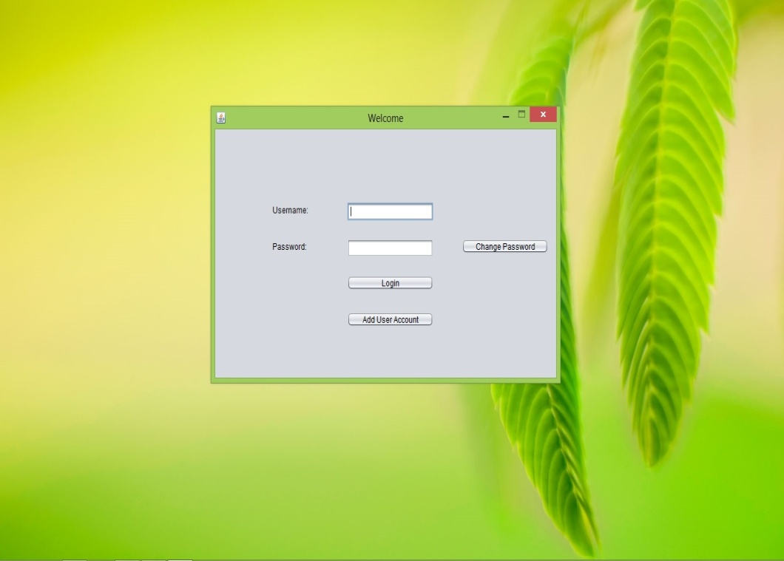

**Security Provided With Usernames And Password:**

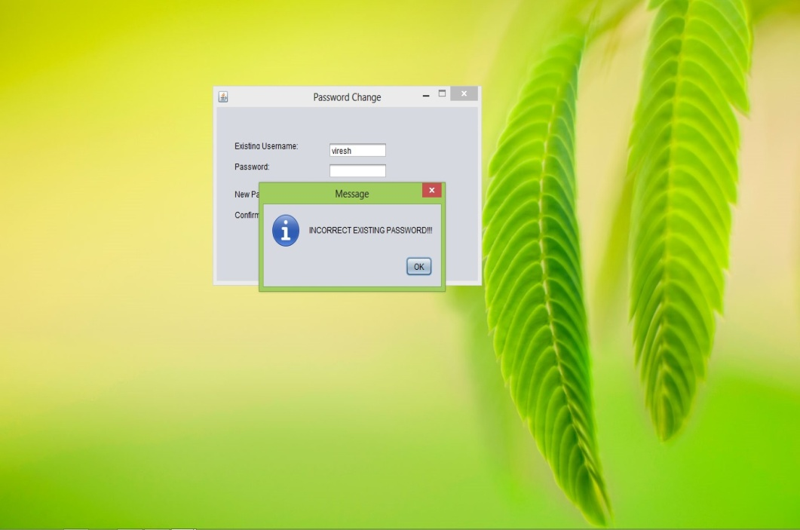

**Adding a New User Account:**

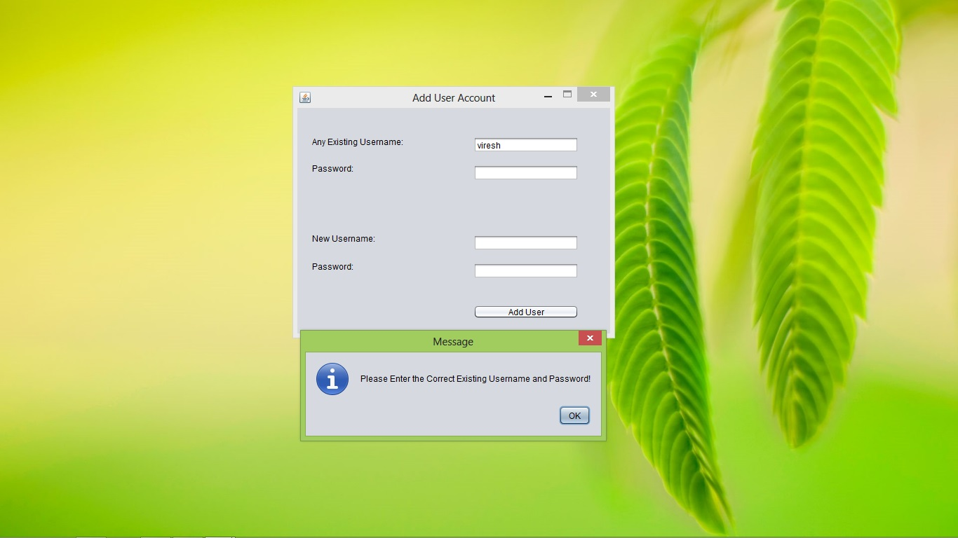

**Opening Of Home Page:**

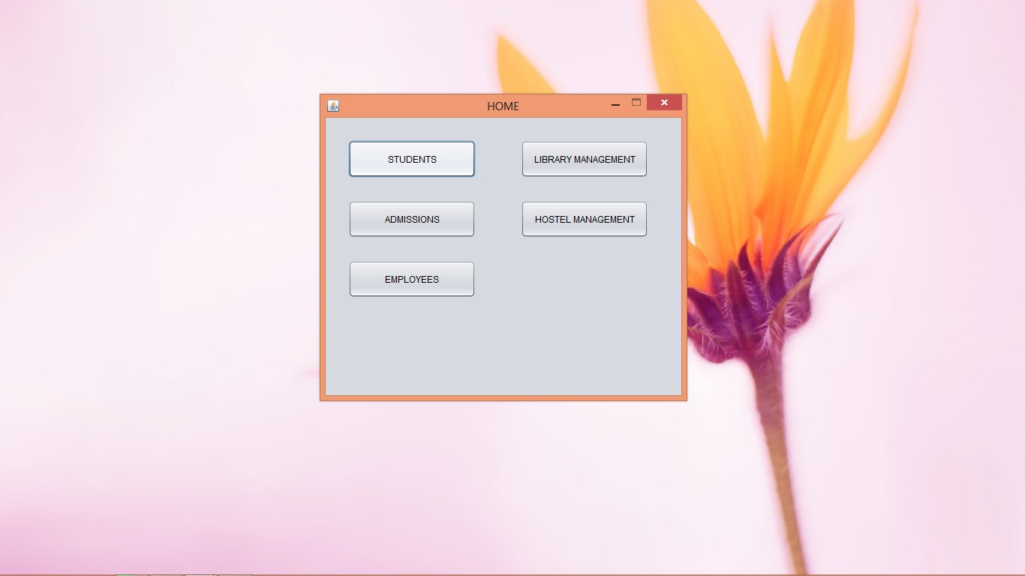

**Opening Of Student Module:**

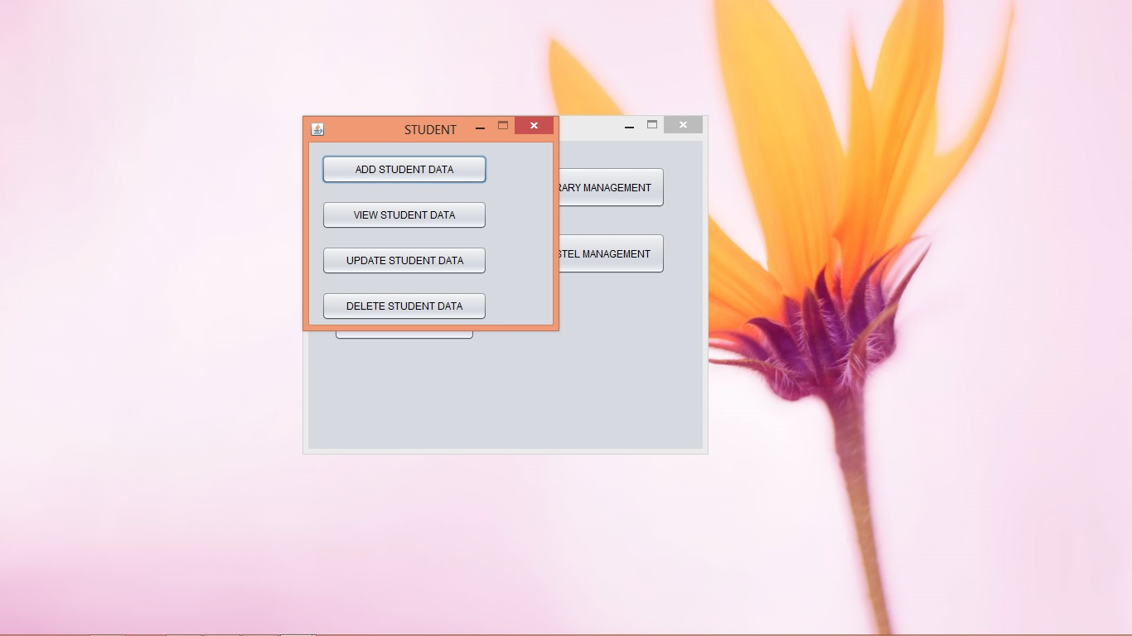

**Updating Student Data:**

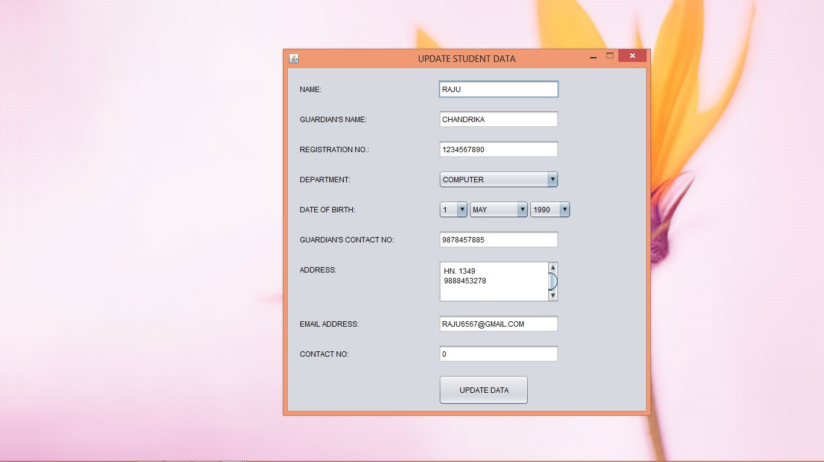

**Opening Of Library Management:**

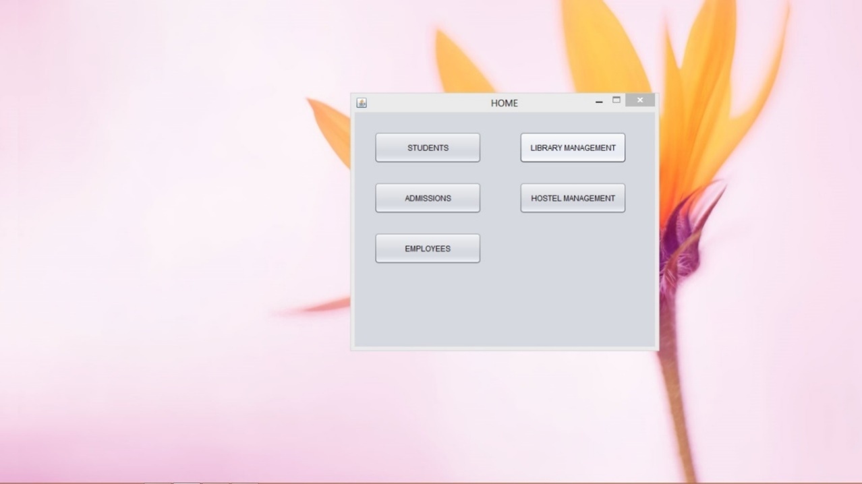

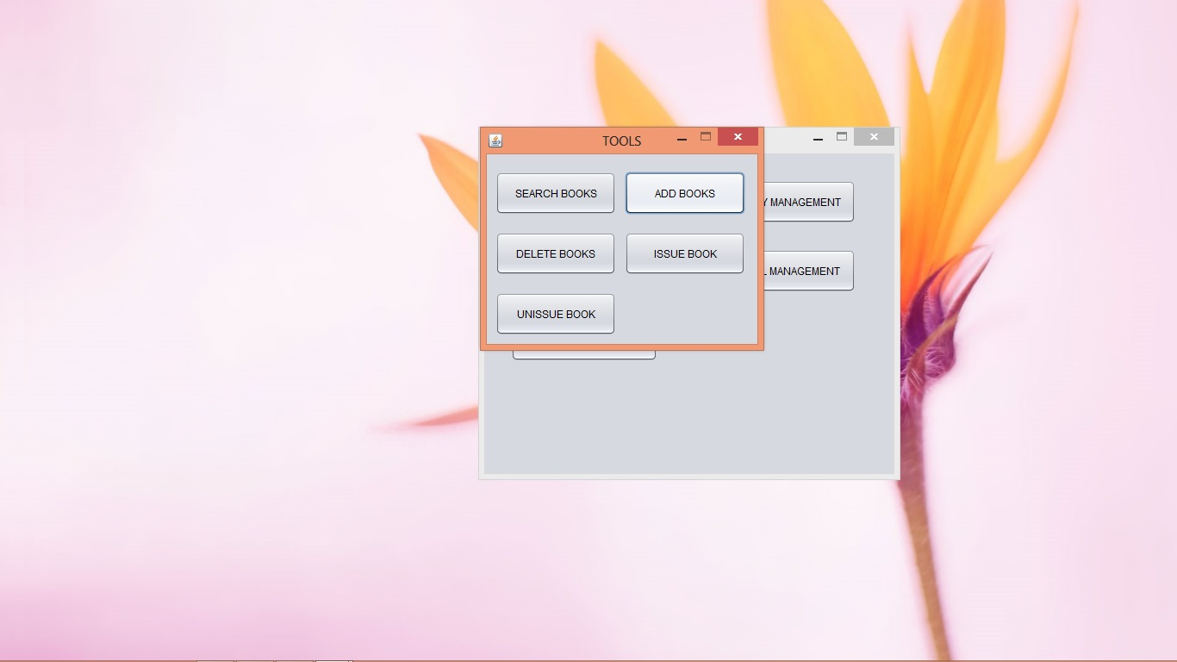

**Opening Of Admissions Module:**

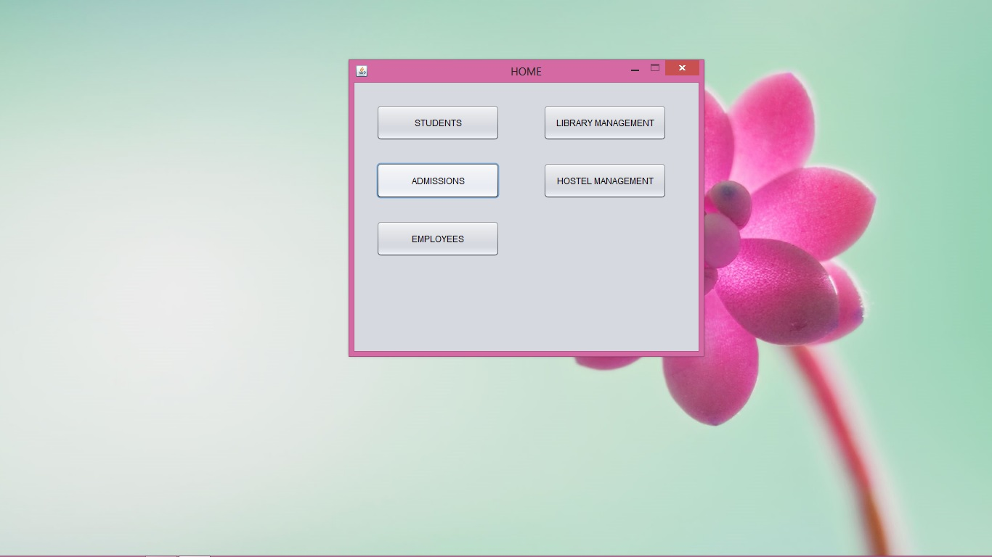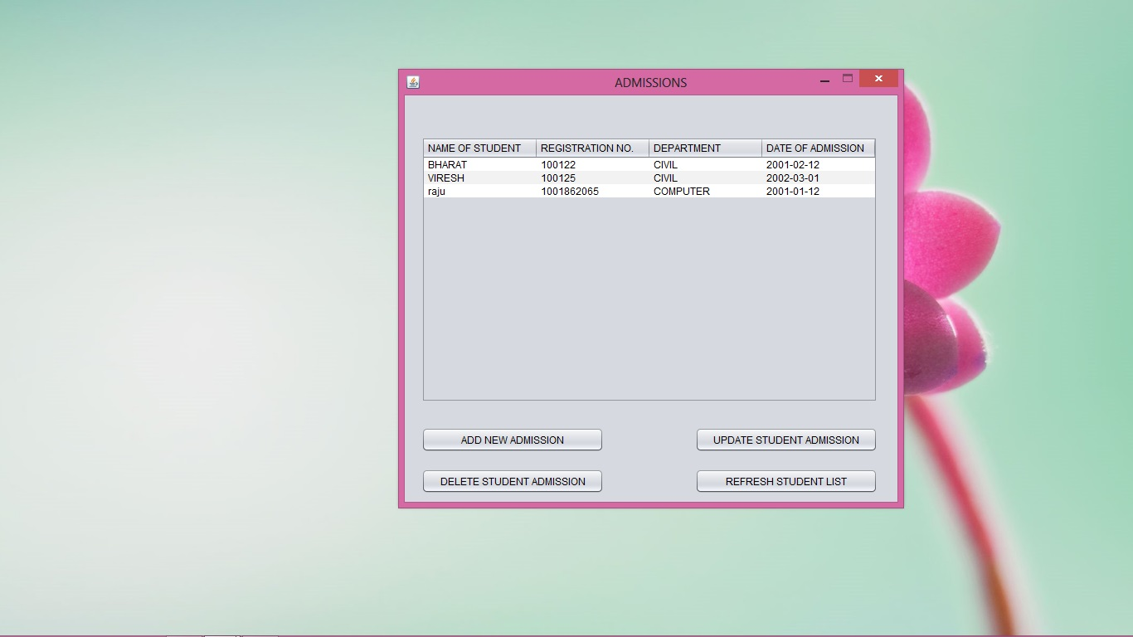

**Hostel Management:**

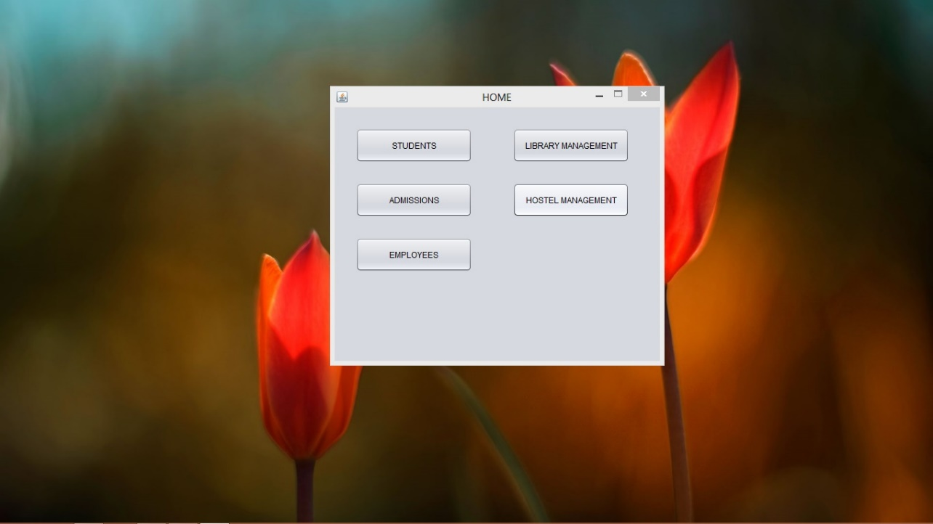

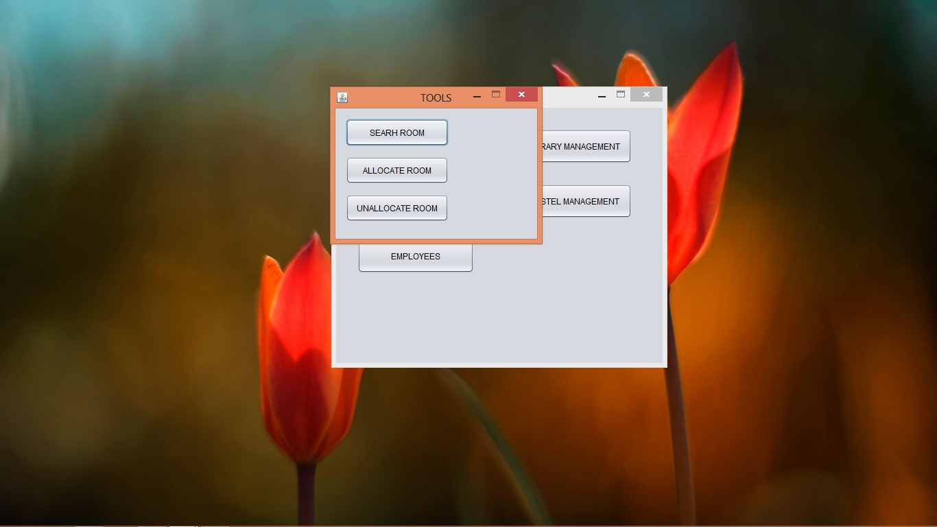

**Opening Of Employee Module:**

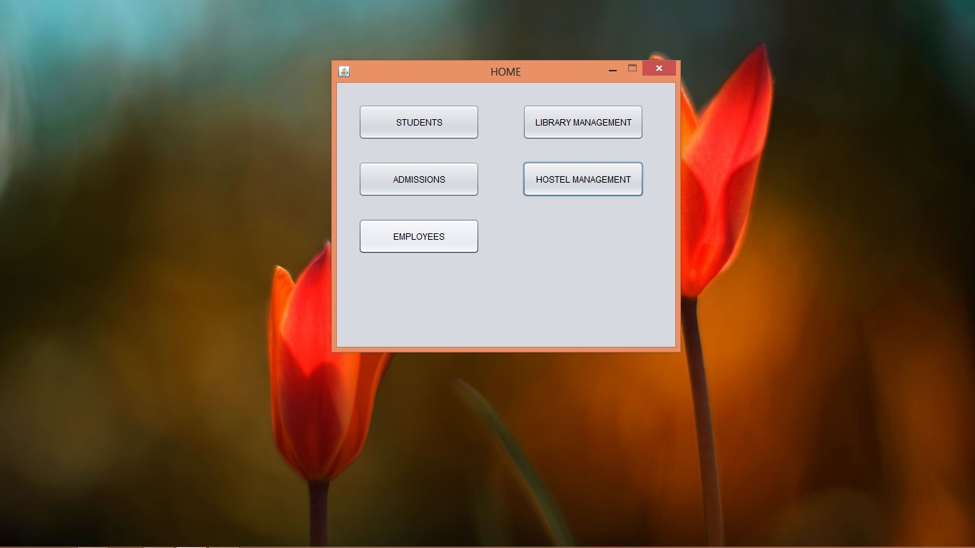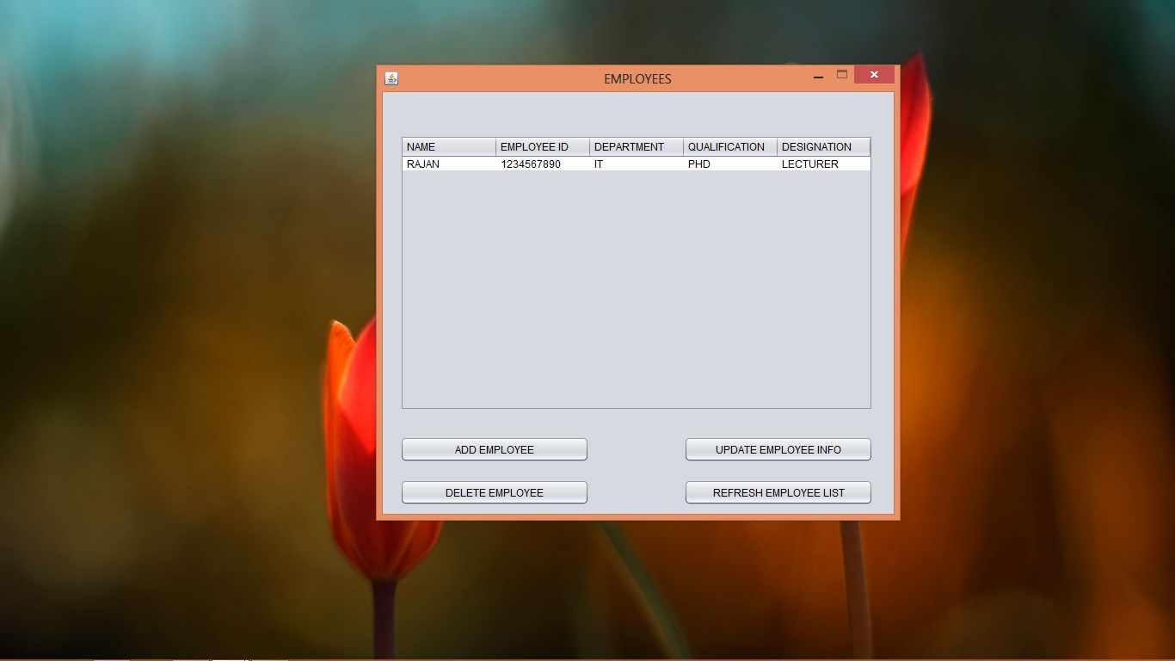

**Data Validations On Employee Module:**

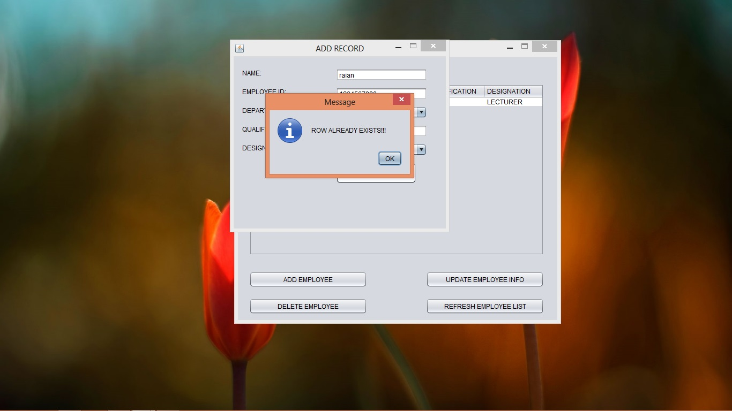

* **DATABASE TABLES OF THE PROJECT:**

**WELCOME TABLE:**

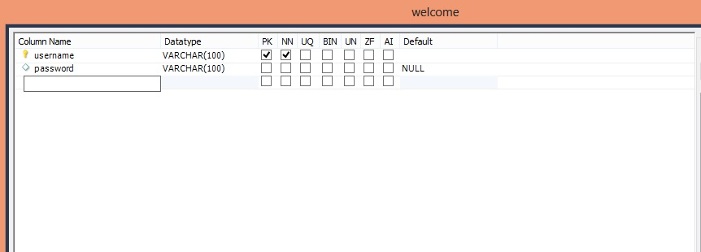

**STUDENTS TABLE:**

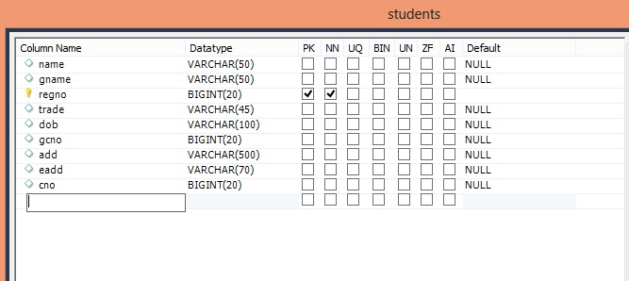

**LIBRARY TABLE:**

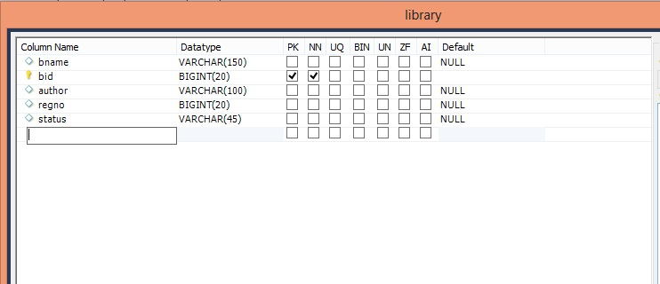

**HOSTEL TABLE:**

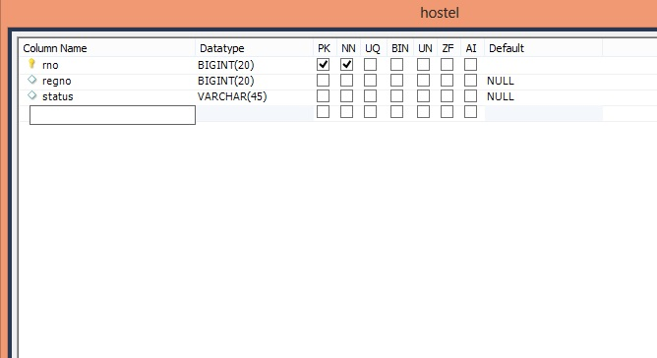

**EMPLOYEES TABLE:**

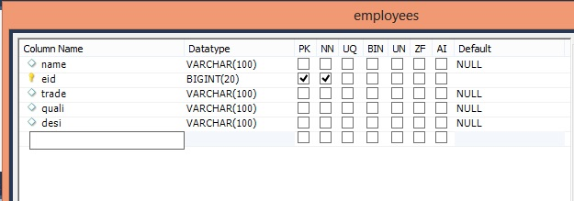

**ADMISSIONS TABLE:**

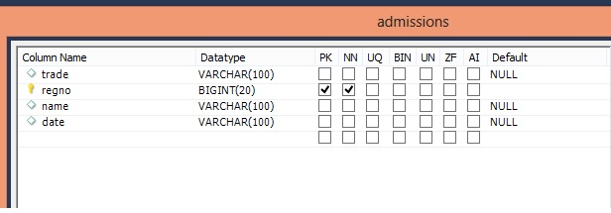

Chapter 5- Conclusions and Future Scope

**Benefits of the Project :-**

* It is a fast , affordable, low-risk solution with easy implementation and lower maintenance and operational costs
* Helps to optimize the use of available resources in a cost effective manner through their proper scheduling and resource allocation.
* Integrates seamlessly into the existing IT infrastructure, hence minimal cost overhead.
* Is an excellent tool to promote and manage enrollment growth and provide accurate enrollment data.
* Acts as a decision support tool for the top management and decision makers by generating real time reports.
* Increase faculty time spent on research and interacting with students
* Reduces information time lag, hence, reducing the pipeline delay for any activity.
* Increases the accountability of the individuals towards their work commitment and foster good working culture in the organization.
* Eliminate duplicate data entry and redundant information storage that most often propagates errors.

**CONCLUSION**

Though a college management software is actually custom based as it is developed for meeting the requirements of a particular college, but we have created the project as a global one which can satisfy the needs of all college system.

Features included in our software are:-

* **Platform Independent :-**As our software is coded in java, so it is platform independent that is it can work on any operating system, whether it be any version of Microsoft windows(98 ME XP VISTA 7), LINUX, UNIX or any other. Reduced data redundancy as we are using RDBMS in the back end of our software, so it will overcome the problem of data duplicity.
* **Fast Execution: -** As our software is GUI based, it contains many new features which will make the execution faster than any other pre-existing software.
* **Cost Efficient: -** Due to removal of data redundancy from the software duplicity of data is eliminated and wastage of memory is overcome. As we know that storage devices are cost consuming so by saving space we are saving money and providing a cost effective software.
* **Inbuilt Security: -** Our software includes better security levels with inbuilt antivirus and anti-hacking facilities which will support the pre-installed antivirus and anti-hacking software’s.

**FURTHER SCOPE OF PROJECT IN FUTURE**

* More College Modules can be added to the project.
* Project can be modified to also work as an attendance system.
* It can be modified to include java servlets to work in co-ordination with many

Online applications.

* **MAINTENANCE**

After a system has been executed and produced satisfactory results, it’s stored as a software package or in system library. The needs of an organization may change with time and a lot more may be expected from the system and this needs either development of a new system or modifications in the existing program. Modification in the system may also be required if it fails to working changed environments, which may be caused by the use of better machines.

The system maintenance means continuous modification and updating of the system to meet the requirements of the users. It’s certainly cheaper than developing a new system. Technical documentation plays an important role in the system maintenance.

Maintenance is the enigma of system development. It holds the software industry captive, typing up programming resources. Analysts and programmers spend far more time maintaining programs then they do writing them. Maintenance can be classified as corrective, adaptive or perfective.

**Maintenance System**

Software system maintenance covers a wide range of activities, including correcting coding and design errors, updating documentation and test data and upgrading user support. It is the process of changing the system to maintain its ability to survive. The system design can adopt any of the under given system maintenance strategies.

**Corrective Maintenance**

The design software can be maintained by corrective maintenance that is concerned with fixing reported errors in the software. Coding errors are relatively cheap to fix as compared to design errors and requirement errors. The requirement errors are more expensive, as redesigning of the entire system is to fix them.

**Adaptive Maintenance**

The design software can be maintained by adaptive maintenance if case there is a need to change the system environment such as a different hardware platform or for using it with different operating system.

**Predictive Maintenance**

The design system can be maintained by predictive maintenance if there is need to implement new functional requirements. They are generated due to the changing requirements of the software customers as their organization or business changes.

**REFERENCES**

* **References from Books**
* Java The Complete Reference Tata McGraw Hill Edition
* Java By SCJP
* **References from Internet**
* [**http://www.mySQL.org**](http://www.mySQL.org)
* [**http://www.wikipedia.com**](http://www.wikipedia.com)
* [**http://www.punjabteched.com**](http://www.punjabteched.com)
* **References from Journal**
* Government Polytechnic College, Amritsar.